**HOW TO APPLY:**

For detailed instructions on how to apply to have cases sealed and to access the application, please visit our website at BrooklynDA.org/Sealing

Kings County DistriCt Attorney's offiCe

SEALING UNIT

**SEALING UNIT**

**Claibourne Henry**

***Unit Chief***

*Parole, Clemency and Sealing Unit Post Conviction Justice Bureau*

Kings County District Attorney's Office

*350 Jay Street*

*Brooklyn, NY 11201* [*sealing@brooklynda.org*](mailto:sealing@brooklynda.org)

**ERIC GONZALEZ**

**DISTRICT ATTORNEY**



***IF YOU ARE NOT A CITIZEN OF THE***

***UNITED STATES*,** *PLEASE BE INFORMED THAT SEALING PURSUANT TO C.P.L.*

*§160.59 does not erase your conviction for immigration purposes.* ***Sealed cases must still be reported for immigration purposes.***

*For more information call: (718) 250-3096*

@BrooklynDA

@BrooklynDA @BrooklynDAOffice

SCAN ME

**ERIC GONZALEZ**

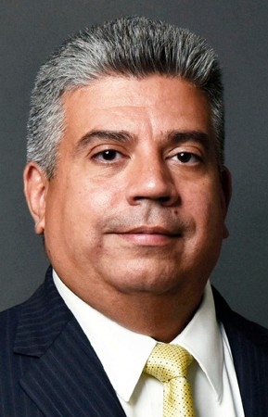

DISTRICT ATTORNEY

The collateral consequences people suffer from past criminal convictions can be devastating. People who are otherwise living law-abiding, productive lives are routinely held back from employment, housing and other opportunities. These past convictions often do not represent the people they are today. I am committed to helping people move on with their lives by sealing convictions when appropriate using New York State's Sealing Statute. I have created a Sealing Unit dedicated to handling these cases.

***IF YOU ANSWERED NO TO ALL OF THE ABOVE QUESTIONS, YOU ARE ELIGIBLE TO HAVE YOUR***

|  |  |  |  |  |
| --- | --- | --- | --- | --- |
|  |  |  |  |  |
| **WHO IS ELIGIBLE FOR SEALING?** | | |
| **1. DO YOU HAVE MORE THAN**  **TWO (2) CRIMINAL CONVICTIONS? (MISDEMEANOR OR FELONY)\***  * If you have more than one conviction that was "committed as part of the same criminal transaction", that counts as a single conviction under this law.  Yes D No D   1. **DO YOU HAVE MORE THAN ONE FELONY CONVICTION?\*\***   ** If you have more than one conviction that was "committed as part of the same criminal transaction", that counts as a single conviction under this law.  Yes D No D   1. **HAVE LESS THAN TEN YEARS PASSED SINCE YOUR CONVICTION?\*\*\***   ***Start counting the ten year period from the date you were sentenced OR, if you were sentenced to incarceration, from the date you were released.  Yes D No D | |  | 1. **ARE YOU REQUIRED TO REGISTER AS A SEX OFFENDER?**   Yes D No D   1. **ARE YOU APPLYING TO SEAL AN INELIGIBLE OFFENSE?\*\*\*\***   **** Ineligible offenses include sex offenses, sexual performance by a child offenses, homicide offenses, violent felony offenses, Class A felonies, felony level conspiracy cases to commit ineligible offenses if the offense still constitutes a felony. A complete list of ineligible offenses appears on the application.  Yes D No D   1. **DO YOU CURRENTLY HAVE AN OPEN**   **CRIMINAL CASE?**  Yes D No D | |

***CASE(S) SEALED. SEE THE REVERSE SIDE FOR DIRECTIONS ON HOW TO APPLY.***

***IF YOU ANSWERED YES TO ANY OF THE ABOVE QUESTIONS, YOU ARE NOT ELIGIBLE TO HAVE***

***YOUR CASE(S) SEALED.***